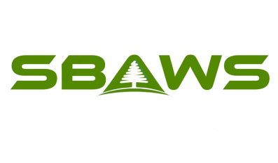

Direct Aid Reimbursement Application

PART A - Personal Information

Name of Person with SB: DOB:

Parent/Guardian (if applicable):

Address: City:

State: Zip: Phone: ( )

Email:

Questions? Contact the Spina Bifida Advocates of Washington State (SBAWS) via email at info@sbaws.org

• All information provided is true and accurate. I realize I will be added to our mailing list to receive SBAWS’ newsletter.
• A Qualified Applicant is a person with Spina Bifida (or that person’s
parent/guardian who resides within the Washington State service area.
• This request is due to financial need. The funds will be used for the intended purposes. I recognize that checks will be made out to the supplier unless paid receipts are included with this application.
• I realize that SBAWS has limited funds and is normally only able to assist up to an annual maximum of $250 and will be awarded at the discretion of the SBAWS Board of Directors.
• You will be contacted about your request from SBAWS to confirm receipt and to assess situation. A final determination will be made at the next scheduled Board meeting (held every month), and you will be notified of the Board’s decision for awarding funding within seven (7) days following that meeting.

X___________________________________________________ Date:____________
Applicant Signature
PART B - Reasons for request for SBAWS Direct Family Aid
Applicant: ______________________________

Intended purpose for the request such as; partial educational and camp scholarship, technology assistance or medical expenses (not covered by existing medical insurance) related directly to the care of the person affected by Spina Bifida:
______________________________________________________________________
______________________________________________________________________
______________________________________________________________________

________Initial/Date
Attached original & legible invoices for Services or Goods:
____________________________________________________________________________________________________________________________________________
______________________________________________________________________

______Initial/Date
Total Amount of Services/Goods per Invoices: ____________________________________________________________________________________________________________________________________________
______________________________________________________________________

______Initial/Date

PART C - Please tell us about your current level of SBAWS participation and/or your interest in future SBAWS participation:

Your support of time and energy is what sustains SBAWS as an organization, therefore is critical to our ability to successfully fulfill our mission. There are many ways you can help us continue: Join event committees, volunteer at events, write articles for newsletter or website, execute a cluster event, actively recruit new members, etc.

Area(s) of current/past participation: ______________________________________
______________________________________________________________________

Area(s) of interest for future participation: _________________________________
______________________________________________________________________

Please mail or email completed applications to SBAWS at -

Mail: SBAWS Email: info@sbaws.org
8404 83rd Ave SW
Lakewood, WA 98498

